 |  |  |  |  | Survey on the Concept of the Symbol
This survey aims at understanding the general public perception of the concept of the symbol on the basis of differences in age, sex, ethnicity, religious beliefs and professional or academic background. The concept of the symbol is a very complex one and there are no correct or incorrect answers. Participants are invited to reply the questions below reflecting on how they genuinely understand and use the word symbol/symbolism.
For the purposes of the survey, it would be recommendable that you give some information regarding personal data:

1) Are you |  |  |  |  |  |  |  |  |  |  |  | 2) Your age
3) State the culture you would identify yourself with: |  |  |  |  |  |  |  |  |  |  |  |  |  |  |  |  |  |  |  | 4) Do you consider yourself religious?
5) State the religion or doctrine you would identify with:
6) What is your profession?
7) What is your educational/Academic background?
1/9 | Would you consider the following images as signs, symbols or both? If you choose both in any of the images, please explain why.
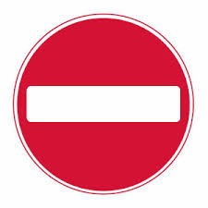 |  |  |  |  |  |  |  |  |  |  |  |  |  |  |  |  |  |  |  |  |  | If both why?
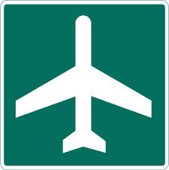 |  |  |  |  |  |  |  |  |  |  |  |  |  |  |  |  |  |  |  |  |  | If both why?
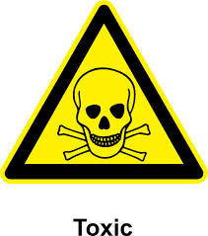 |  |  |  |  |  |  |  |  |  |  |  |  |  |  |  |  |  |  |  |  |  | If both why?
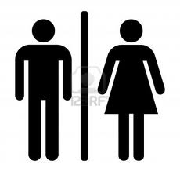 |  |  |  |  |  |  |  |  |  |  |  |  |  |  |  |  |  |  |  |  |  | If both why?
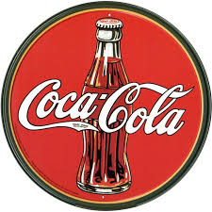 |  |  |  |  |  |  |  |  |  |  |  |  |  |  |  |  |  |  |  |  |  | If both why?
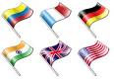 |  |  |  |  |  |  |  |  |  |  |  |  |  |  |  |  |  |  |  |  |  | If both why?
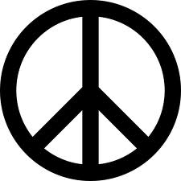 |  |  |  |  |  |  |  |  |  |  |  |  |  |  |  |  |  |  |  |  |  | If both why?
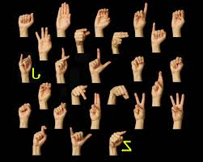 |  |  |  |  |  |  |  |  |  |  |  |  |  |  |  |  |  |  |  |  |  | If both why?
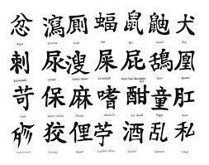 |  |  |  |  |  |  |  |  |  |  |  |  |  |  |  |  |  |  |  |  |  | If both why?
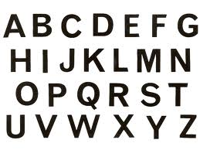 |  |  |  |  |  |  |  |  |  |  |  |  |  |  |  |  |  |  |  |  |  | If both why?
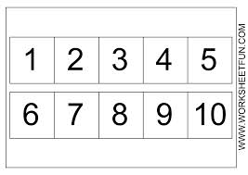 |  |  |  |  |  |  |  |  |  |  |  |  |  |  |  |  |  |  |  |  |  | If both why?
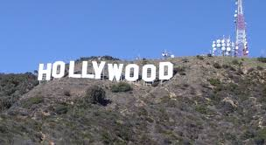 |  |  |  |  |  |  |  |  |  |  |  |  |  |  |  |  |  |  |  |  |  | If both why?
 |  |  |  |  |  |  |  |  |  |  |  |  |  |  |  |  |  |  |  |  |  | If both why?
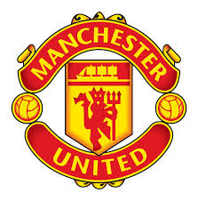 |  |  |  |  |  |  |  |  |  |  |  |  |  |  |  |  |  |  |  |  |  | If both why?
 |  |  |  |  |  |  |  |  |  |  |  |  |  |  |  |  |  |  |  |  |  | If both why?
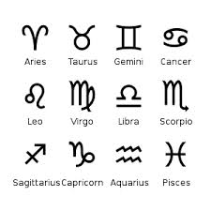 |  |  |  |  |  |  |  |  |  |  |  |  |  |  |  |  |  |  |  |  |  | If both why?
 |  |  |  |  |  |  |  |  |  |  |  |  |  |  |  |  |  |  |  |  |  | If both why?
2/9 | After answering the above questions how would you describe the difference between symbols and signs? You can choose more than one options
The sign is specific while the symbol is abstract

The sign is abstract while the symbol is specific

The sign implies action or ways of use while the symbol is more abstract
The symbol has more powerful impact than a sign

The sign has a more powerful impact than the symbol
Other, please describe:
…

3/9 | Observe carefully the differences and similarities between the 4 images below and say which you would classify as signs and which as symbols?
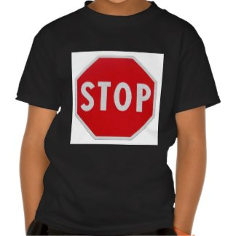 |  |  |  |  |  |  |  |  |  |  |  |  |  |  |  |  | 
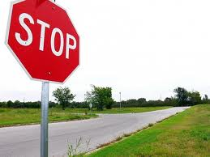 |  |  |  |  |  |  |  |  |  |  |  |  |  |  |  |  | 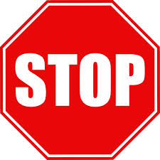
If you see any symbols, please explain why…
…

4/9 |  |  | Would you consider the following as symbols and if yes of what?
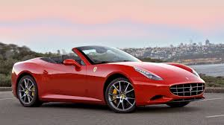 |  |  |  |  |  |  |  |  |  |  |  |  |  | 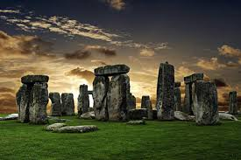
 |  |  |  |  |  |  | Of what? |  |  |  |  |  |  |  |  |  |  |  |  |  |  |  |  |  |  | Of what?
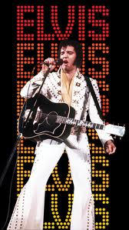 |  |  |  |  |  |  |  |  |  |  |  |  |  | 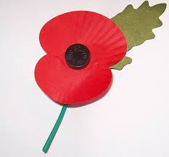
 |  |  |  |  |  |  | Of What? |  |  |  |  |  |  |  |  |  |  |  |  |  |  |  |  |  |  | Of what?
Do you find that these images: |  |  |  |  |  |  |  |  |  |  |  |  |  | Did you find it easy to specify what they represent?
Represent more than one idea at the same time |  |  |  |  |  |  |  |  |  |  |  |  |  | I replied immediately |  |  |  |  |  |  |  |  |  | I had to think for a while
Represent one very specific idea alone |  |  |  |  |  |  |  |  |  |  |  |  |  | It was quite confusing |  |  |  |  |  |  |  |  |  | I am still not sure of my answer
5/9 |  | Which of the following 3 images would you find as having the most powerful impact?
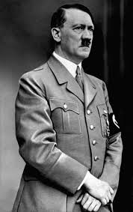 |  |  |  |  |  |  |  |  | 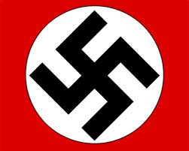 |  |  |  |  |  |  |  |  |  |  |  | 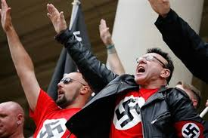
How would you explain your choice?
…

6/9 | Would you consider any of the images below as more symbolic than others?
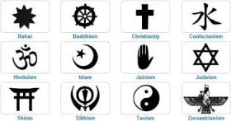

If yes, which and why would you think so?
…

7/9 | Which of the images below would you consider as more symbolic?
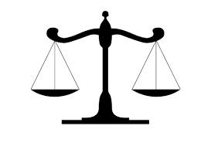 |  |  |  |  |  |  |  |  |  |  |  |  |  |  | Why do you think so?
 |  |  |  |  |  |  |  |  |  |  |  |  |  |  | …
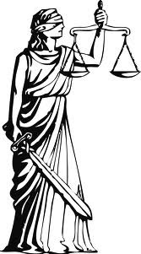


8/9 | Which of the 3 images below would you consider as symbolic and why?
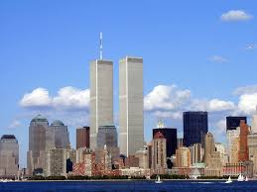 |  |  |  |  |  |  |  |  |  | 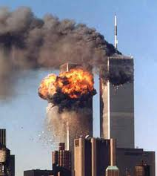 |  |  |  |  |  |  |  |  |  |  |  |  | 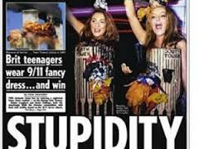
Why?
…

9/9 | Which of the two in each pair would you consider more symbolic and why?
Pair A | 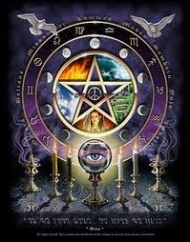 |  |  |  |  |  |  |  |  |  |  |  |  |  |  |  |  |  | 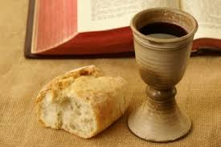
Why? | …
Pair B | 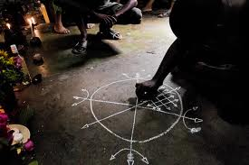 |  |  |  |  |  |  |  |  |  |  |  |  |  |  |  |  |  | 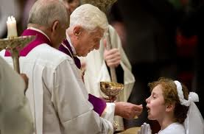
Why? | …
Pair C |  |  |  |  |  |  |  |  |  |  |  |  |  |  |  |  |  |  | 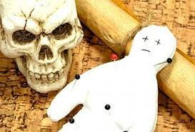
Why? | …
Pair D
Why? | …
Thank you very much for your participation! Now please save the completed survey before then emailing it as an attachment to: elena.soulioti@durham.ac.uk The research findings will be announced at the ‘Conceptual boundaries of Symbolism’ workshop (and made available online at www.duruniarchsoc.co.uk/news from early February 2014).

