MEDITERRANEAN NARRATIVES
A New Research-Focused Seminar Series
Department of Art of Ancient Greece and Rome, MFA Boston
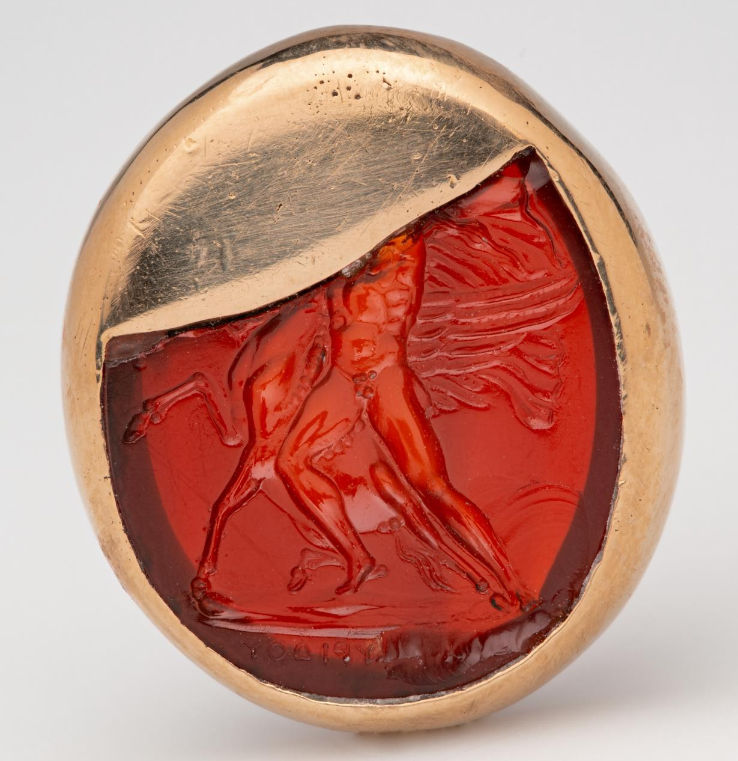
Searching for Dioskourides: A work in progress
Ken Lapatin, Curator of Antiquities at the J. Paul Getty Museum
Friday, November 6, 1pm EST
Dioskourides is one of few gem engravers mentioned by ancient authors. He is explicitly named by Pliny the Elder and Suetonius as the carver of Augustus’s principal seal, a work is also referenced by Dio Cassius. He is, moreover, named by three sons who followed him in the profession. Unlike most other renowned artists whose names are preserved by Greek and Latin writers (e.g., Pheidias, Polykleitos, Zeuxis, Apelles), some of his work actually survives to this day. Such objects, unsurprisingly, have long been prized by post-antique collectors and scholars. This paper is divided into three parts. First, a brief review of the ancient written sources. Second, a re-examination of the material evidence, based, so far as possible, on autopsy: more than 200 gems (cameos as well as intaglios) bear inscriptions that purport to be Dioskourides’s signatures, and modern scholars have attributed several other, unsigned engraved stones to his hand and/or “workshop”. Most of these, however, are demonstrably modern. Evaluating the remaining gems and establishing a secure corpus is crucial to gaining to a better understanding of this important craftsman, and the situation is further complicated by the practice of adding false signatures to previously uninscribed ancient gems as well as the production in the early modern period of hardstone replicas (not necessarily forgeries) of signed ancient gems that appear to be lost. Thus, methodological considerations are paramount, and criteria for inclusion or exclusion should be made more explicit than has been customary hitherto. Third, some general observations about the artist and his legacy will, so far as possible, be drawn from parts one and two.
Register for this virtual seminar here: https://us06web.zoom.us/meeting/register/Dy-k_I7sT_y79IyiweIXUg
Image credit: Dioskourides, Oval gem with Bellerophon mastering Pegasus, about 50–30 B.C. MFA Boston, 27.737

